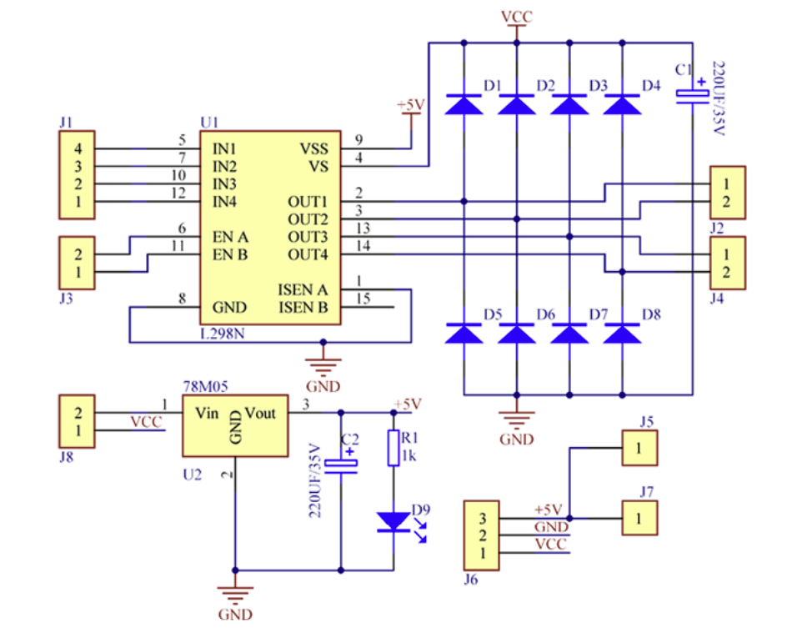

* **J1**: This connector is for input signals coming from your control unit, which in your case is the **ESP32**.
* **Pin 1 (IN4)**: This pin corresponds to **IN4** on the L298N driver. It controls the direction of motor 2. The signal for this pin should be stepped up from **3.3V (ESP32 output)** to **5V**, since the L298N requires a 5V logic level.
* **Pin 2 (IN3)**: Similarly, this pin corresponds to **IN3** and controls the other direction of motor 2. Again, it should receive a **5V logic** signal.
* **Pin 3 (IN2)**: This pin corresponds to **IN2** and controls the direction of motor 1. The signal should also be stepped up to **5V**.
* **Pin 4 (IN1)**: This pin corresponds to **IN1** and controls the other direction of motor 1, requiring the same **5V logic level**.

### **Voltage Requirements for J1 Pins:**

* **IN1, IN2, IN3, IN4**: The input logic for the L298N motor driver requires **5V logic signals**. Since your ESP32 operates at **3.3V**, these signals are being stepped up to **5V** before reaching the L298N driver. The voltage you should use for these inputs is **5V**, which is correctly being done by the step-up circuit in your setup.
* **J3** is connected to the **Enable pins** of the L298N motor driver. These enable pins control whether the outputs are active, effectively enabling or disabling the motors.

Here’s the breakdown of **J3** pins:

* **Pin 1**: This connects to **EN A** (Pin 6 on the L298N), which controls the **enable** signal for **motor 1** (the motor connected to OUT1 and OUT2).
* **Pin 2**: This connects to **EN B** (Pin 11 on the L298N), which controls the **enable** signal for **motor 2** (the motor connected to OUT3 and OUT4).

### **Voltage Requirements for J3:**

* The **EN A** and **EN B** pins are used to control whether the motors are active or not. These pins typically require a **PWM signal** (Pulse Width Modulation) to control the motor's speed, or a simple **5V signal** to turn the motor on at full speed.
* In your case, since you're stepping up the signals from the ESP32 (which operates at 3.3V) to **5V**, these enable signals will also need to be at **5V**. If a **5V PWM signal** is sent to EN A or EN B, the motor will run at the speed determined by the duty cycle of the PWM.
* If you want to turn the motors on at full speed, you can send a continuous **5V signal** to these pins. If you want to control speed, a **PWM signal** with a frequency (typically around 1kHz to 20kHz) would be sent.

### **Summary of J3:**

* **Pin 1 (EN A)**: Controls the enablement of motor 1. Requires a **5V signal** or **5V PWM** to control motor speed.
* **Pin 2 (EN B)**: Controls the enablement of motor 2. Also requires a **5V signal** or **5V PWM**.

The **VSS** pin on the **L298N motor driver** is an important part of the circuit that provides the **logic supply voltage** to the IC. Let me explain its role and what it connects to in your schematic:

### **VSS Pin (Pin 9 on the L298N):**

* The **VSS** pin is the **logic voltage supply pin** for the L298N. This pin powers the internal logic circuits (like the input logic and control circuitry) of the L298N motor driver.
* In your schematic, **VSS** is connected to a **+5V supply**.

### **Why +5V for VSS?**

* The **L298N** operates with **5V logic** for its control inputs (IN1 to IN4, EN A, and EN B). Therefore, the **VSS pin** must be connected to a **+5V supply** to ensure that the internal logic circuits work correctly.
* This **+5V** power supply typically comes from a **voltage regulator** (like the 7805 in your schematic) that steps down the voltage from your higher voltage source (in your case, a **7.4V Li-Ion battery**) to a stable **5V**.

The **VS** pin on the **L298N motor driver** is the **power supply pin for the motors**. This pin provides the voltage that powers the motors connected to the driver. Here's a detailed explanation of its function and connections:

### **VS Pin (Pin 4 on the L298N):**

* The **VS** pin supplies the **power** to the motors being controlled by the L298N. This is the voltage that will be delivered to the motors via the OUT1, OUT2, OUT3, and OUT4 pins.
* In your case, **VS** is connected to the **7.4V Li-Ion battery**. This means that the motors connected to the L298N will be powered by the full 7.4V from the battery.

### **Role of VS:**

* The **VS** pin provides the necessary **high-current power** to drive the motors. This is separate from the **logic voltage** (which is supplied through the VSS pin and powers the internal logic of the L298N).
* The voltage on the **VS pin** is what ultimately drives the motors. For example, if you connect 7.4V to VS, the motor will receive a voltage between 0V and 7.4V depending on the control signals (IN1-IN4) and PWM duty cycle.

### **VS in Your Schematic:**

* In your diagram, the **VS pin** is directly connected to the **7.4V battery**. This means:
  + The motors will receive up to **7.4V** (depending on how the L298N controls the output).
  + This voltage is used to power the **OUT1, OUT2, OUT3, and OUT4** pins, which are connected to the motors at **J2** and **J4**.
* The **diodes (D1 to D8)** placed near the output side of the L298N (connected to the motor outputs) are **flyback diodes**. They protect the L298N driver from voltage spikes that occur when the motor's inductive load (the motor coils) switches off or changes direction. These diodes are crucial for protecting the circuit, especially at higher voltages like **7.4V**.